Chapter 16, Problem 90.

Develop the state equations for the circuit shown in Fig. 16.104.

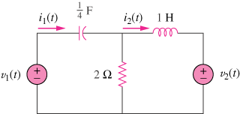

Figure 16.104
For Prob. 16.90.

